**Inventorist Professional Software**

**User Guide**



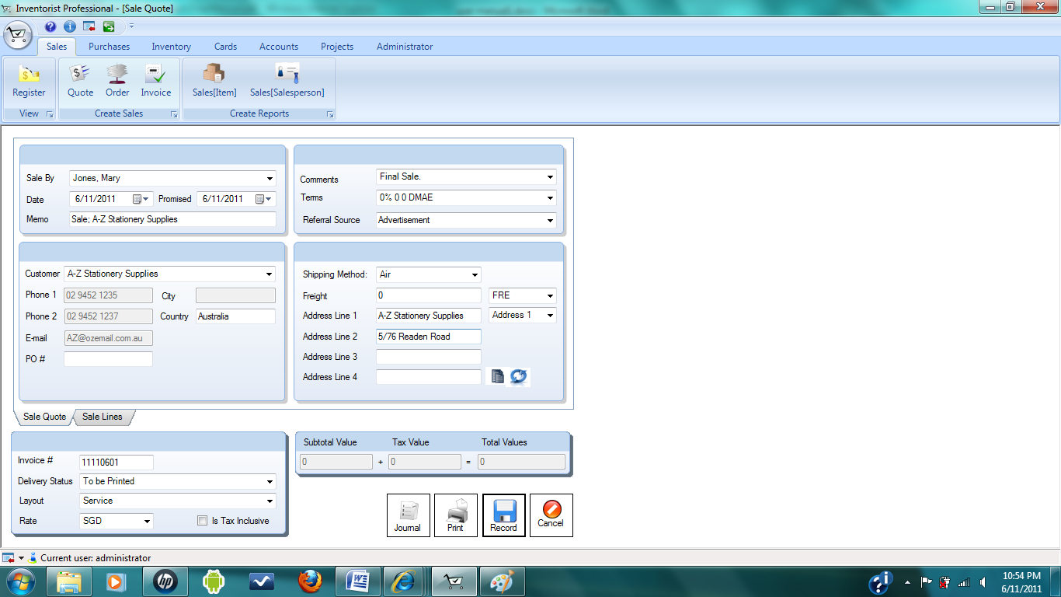



**Contents Page**

Chapter 1 Getting started 5

1.1 Using the manual 5

1.2 Creating a new company file 5

1.3 Starting DacII Software 5

1.4 Command Centre 6

1.5 Menu Bar and Ribbon 7

1.5.1 Application menu 7

1.5.2 Quick Access Toolbar 8

1.6 Ribbon Tabs and Chunks 8

Chapter 2 Setting Up 9

2.1 Set up accounts 9

2.2 Review the account lists 10

2.3 Update the account 10

2.4 Log in feature 11

2.5 Creating New User 14

2.6 Creating New Role 15

2.7 Creating New item size 16

2.8 Creating new gender 17

2.9 Creating new additional fields 18

Chapter 3 Sales 19

3.1 Creating Customer card 19

3.2 Entering Sales 21

3.2.1 Create sale quote 22

3.2.2 Create sale order and sale invoice 23

3.3 Converting the sale quote to a sale order or an invoice 23

Chapter 4 Purchase 24

4.1 Creating Supplier card 24

4.2 Entering Purchases 26

4.2.1 Create purchase quote 27

4.2.2 Create purchase order and open bill 28

4.3 Converting the purchase quote to a purchase order or a bill 28

Chapter 5 Inventory 29

5.1 Creating Items 29

5.1.1 Average Cost, Last Cost and Standard Cost 32

5.2 Reviewing inventory information 33

5.3 Changing Transaction 34

Chapter 6 Setting up Employee data 34

6.1 Creating Employee Card 34

Chapter 7 Working with accounts 36

7.1 Deleting user 36

7.2 Deleting role 37

7.3 Deleting item size 37

7.4 Deleting gender 38

7.5 Deleting additional fields 39

7.6 Updating the Customer card 40

7.7 Updating the Supplier card 40

7.8 Updating the Employee card 41

Chapter 8 Working with data 42

8.1 Backup and restore 42

8.2 Erase the contents 43

Chapter 9 Working with projects and jobs 44

9.1 Reviewing the projects 44

9.2 Updating the project 44

9.3 Reviewing the Jobs 45

**Figures Pages**

Figure 1: Command Centre window 6

Figure 2: Useful area in DacII window 7

Figure 3: Application menu 7

Figure 4: Ribbon tabs and their respective chunks 8

Figure 5: Window displaying list of accounts 10

Figure 6: Log in dialog 11

Figure 7: Error dialog appeared for undefined user 12

Figure 8: Error dialog appeared for invalid password 12

Figure 9: Main menu 13

Figure 10: Window showed list of users 14

Figure 11: Dialog to create new user 14

Figure 12: Window showing list of roles 15

Figure 13: Dialog to create new role 15

Figure 14: Window showed list of items created and dialog to create new item list 16

Figure 15: Window showed list of gender 17

Figure 16: Window showed list of additional fields 18

Figure 17: Window showing list of customers 19

Figure 18: Customer dialog showing profile page 20

Figure 19: Customer dialog showing selling details page 20

Figure 20: Sale quote dialog 22

Figure 21: Sale quote window and service sale line dialog 23

Figure 22: Window showing list of suppliers 24

Figure 23: Supplier dialog 25

Figure 24: Supplier dialog showing selling details page 25

Figure 25: Purchase quote dialog 27

Figure 26: Purchase quote window and service purchase line dialog 28

Figure 27: Item window showing profile page 30

Figure 28: Item window showing buying details page 31

Figure 29: Item window showing selling details page 31

Figure 30: Item register window 33

Figure 31: Employees window 34

Figure 32: Employee dialog showing profile page 35

Figure 33: Window showing list of users 36

Figure 34: Window showing list of roles 37

Figure 35: Window showing list of items 38

Figure 36: Window showing list of gender 38

Figure 37: Window showing list of additional fields 39

Figure 38: Customer window 40

Figure 39: Supplier window 41

Figure 40: Backup window 42

Figure 41: Backup window showing information for MSSQL page 42

Figure 42: Backup window showing for cloud backup page 43

Figure 43: Erase contents window 43

Figure 44: Projects window 44

Figure 45: Job dialog 45

Figure 46: Job window showing information for jobs 45

# Chapter 1 Getting started

Today much software is offered for small and medium scale companies to monitor corporate performance. Features between one product and others are sometimes almost identical. Nowadays, small or large companies use MYOB which is [Accounting & Business Software & Services, Payroll Software](http://en.wikipedia.org/wiki/Accounting_software). Although MYOB is well known, it has some weaknesses such as poor reporting, difficulties in customization or modification of fields in database, difficulties for taxation and treatment of historical data. DacII software is designed to solve some of the difficulties found in MYOB.

DacII software is designed simply to allow you to keep track of your important financial information. You can find easily all the functions you need to use with the help of its neat design. You can complete your work as it can provide more sophisticated features. By using this software, you can finish your accounting jobs as quickly as possible and you can make your customers and clients happy.

## 1.1 Using the manual

This manual will help you to use DacII software in easy way and it will guide you to use comprehensive learning tools to understand the fundamentals of the business routines. By using the tools, you can easy solve the problems encountered in your everyday work.

## 1.2 Creating a new company file

## 1.3 Starting DacII Software

Before starting to do your job using DacII software you need to know how to start the software. To load DacII software, do the following steps.

1. Click on the **Start** menu in the bottom left corner of the screen

2.Choose **All Programs** then **DacII folder** (from the sub-menu which appears)

3.Finally click on **DacII**

**Note:** You'll probably be using the software quite often in the future, so it's useful to put it as an icon on the *Desktop*. To do this, repeat the above steps, and at the last step, press *right mouse button* and choose “**Send To”** followed by **Desktop (create shortcut)**. After creating the icon on the desktop, simply double click t*he icon* on the *Desktop*.

## 1.4 Command Centre

Command centre is the central location of the inventory management system. There are six command centres and they are **Accounts, Banking, Sales, Purchases, Inventory** and **Card File**. When you start and log in to the system, the command centre window will be always displayed on main menu.

There are shortcut links to related tasks and functions under each command centre. For example, from the **Sales** command centre, you can register sales, enter sales, print invoice and record transaction journal.

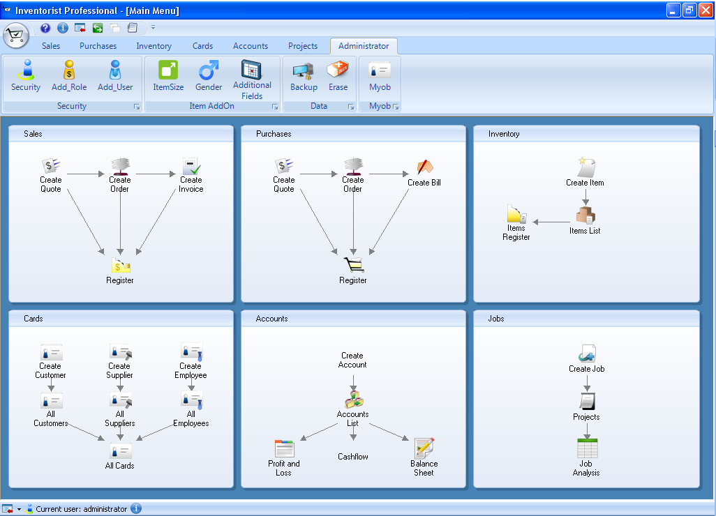

**Tasks or functions related to the current centre are displayed and you can go the related windows by clicking them**

**Figure 1: Command Centre window**

When you want to go to the command centre window from other window that you are working with, you can click the button from quick access tool bar as shown below.

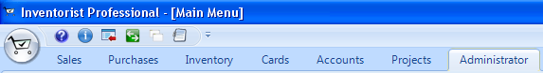

## 1.5 Menu Bar and Ribbon

The menu bar will help you to find and access all the tasks and functions. Window called **Inventorist Professional** window contains several important areas as shown below. Those area includes application menu and ribbon tabs. Some detail explanation for menu and ribbon tabs can be seen as below.

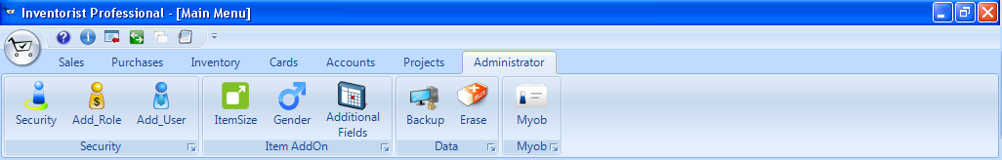

**Figure 2: Useful area in DacII window**

A. Application menu Go to main menu, company tab and exit application.

B. Quick Access Toolbar It contains icons to access to help, license agreement, main menu and exit

C. Window Controls Buttons to minimize, maximize and close the window.

D. Ribbon Tabs Each tab contains a different set of options relevant to the tab name.

E. Chunks Each ribbon is divided into various parts called chunks.

F. Help Icon Click the question mark icon to see the Help screen.

### 1.5.1 Application menu

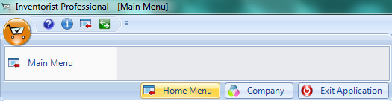

Figure 3: Application menu

A. Home menu go to main home menu

B. Company

C. Exit Exit the application

### 1.5.2 Quick Access Toolbar

 Help menu – Click this icon to find the documents or manual.

 License agreement – Click this icon to see the license agreement information.

 Go to main menu – Click this icon to go to main menu.

 Hide and unhide ribbon menu – Click this icon to hide the ribbon

## 1.6 Ribbon Tabs and Chunks

There are altogether seven ribbon tabs as shown below. They are Sales, Purchases, Inventory, Cards, Accounts, Projects and Administrator. For each tab, there are different chunks which are divided according to different features. From the following figure, you can see all different chunks under **Administrator Ribbon tab** and they are divided by features such as Security, Item Add On and Data.

**Administrator ribbon tab**

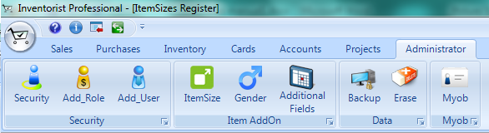

**Different chunks which are divided according to different features**

Figure 4: Ribbon tabs and their respective chunks

Administrator To add and delete new user, role, Item and backup and delete data

Projects To check and print projects and jobs

Accounts To view the account lists, transaction journals, balance sheet and profit & lost

Cards To view, add and delete information of customer, employee and supplier

Inventory To view and search information of items and record new item

Purchases To view purchase information and record new purchase

Sales To view sale information and record new sale

# Chapter 2 Setting Up

In this chapter, you will learn about your accounts, log in feature, user accounts and your jobs. It will show the initial set up including setting up accounts, items and jobs.

## 2.1 Set up accounts

Accounts will keep track of the additions and subtractions that will occur in regular business activity. You need to set up the accounts properly as they are the mainstay of you financial records.

There are six types of accounts which are Asset, Liability, Equity, Income, Cost of Sales and Expense.

**Asset** This type indicates all the things that your company or business possess. They can be cash, cheque account, inventory, equipment, furniture, money that people owe you and etc.

**Liability** This type indicates all the things that your company or business owes. They can be loans, mortgages, credit cards and money that you hold but owed to someone or somewhere else (example: customer deposits).

**Equity** This type indicates your stake in the company (example: retained earnings).

**Income** This includes the money you or your company receive for items or services sold.

**Cost of Sales** This type indicates the direct costs of products and/or services which are sold by your company. The common accounts are raw materials and manufacturing labour costs.

**Expense** This type indicates all expenses that you incurred to run a business. They can be renting office, advertising, travel, legal fees and etc.

## 2.2 Review the account lists

To review the account lists created

* Go to Accounts ribbon tab
* Click Accounts list view button
* All the accounts created will be displayed under all accounts tab

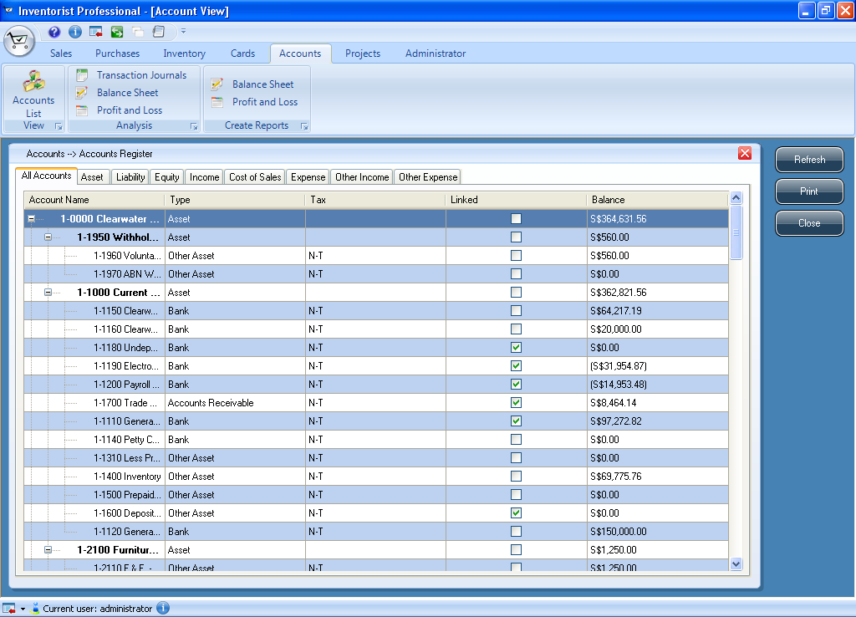

**List of all accounts created**

Figure 5: Window displaying list of accounts

## 2.3 Update the account

## 2.4 Log in feature

After launching DacII, first thing you need to do is to log in as a user. There will be default user which is “Administrator” and you also can create new user accounts with different roles. Creating the user will be discussed in later part of this chapter. The followings are steps and information for log in feature.

To log in as a default user:

1. Launch DacII and **default** user name should be “**Administrator**” when log in dialog comes out.
2. Log in as Administrator using password “chen0469”. Same procedure can be used for all users with different roles.
3. If “cancel” button is clicked, DacII will exit.
4. If cross icon  is clicked, DacII will exit.

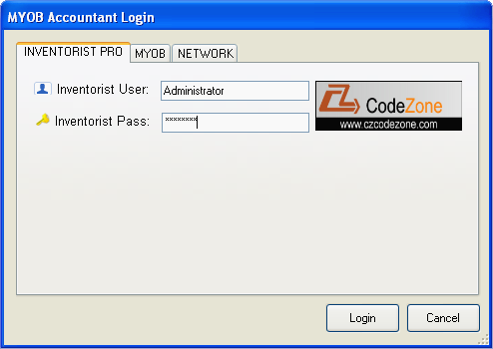

**Enter user name**

**Enter password**

Figure 6: Log in dialog

1. If user name, which has never been created, is used error dialog is appeared as shown below.

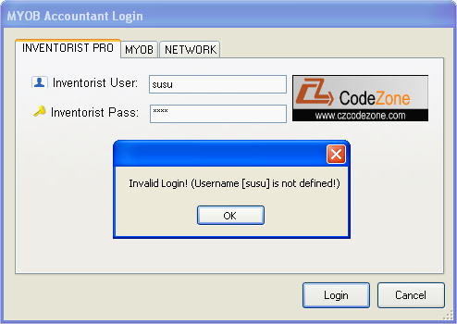

**Dialog appeared when log in with invalid user name**

Figure 7: Error dialog appeared for undefined user

1. If invalid password is used, error dialog is appeared as shown in figure.

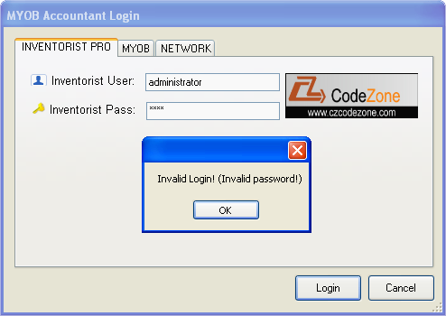

**Dialog appeared when log in with invalid password**

Figure 8: Error dialog appeared for invalid password

1. If log in as Administrator, main menu should have all feature tabs which are Sales, Purchases, Inventory, Cards, Accounts, Projects and Administrator as shown below.
2. If log in as user which is not administrator role, “Administrator” tab will not be included in main menu.



Administrator tab

Figure 9: Main menu

## 2.5 Creating New User

New user can be created using different roles which can also be created. To create new user, log in to DacII as user with administrator role (log in as default user). After that, do the following steps to add new user:

1. Go to **Administrator ribbon Tab** and click **Add_User button**

**(OR)**

1. Go to **Administrator ribbon Tab** and click **Security button** and click **Create User button** which is at the bottom corner of the window
2. Type user name and password and choose for role and employee.

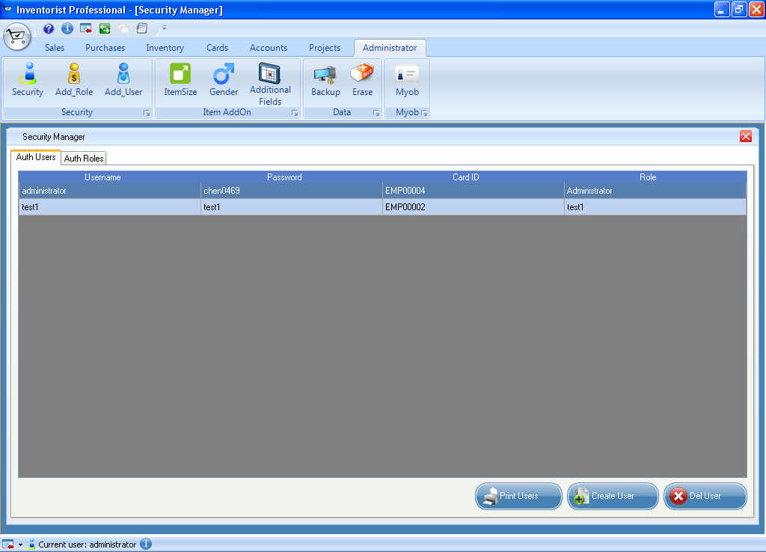

Figure 10: Window showed list of users

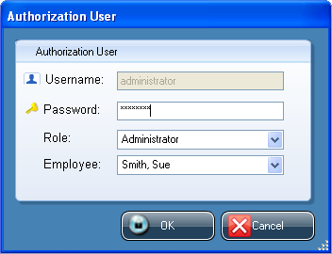

Figure 11: Dialog to create new user

## 2.6 Creating New Role

As same with user, user role can be created according to their specification. To create new role, log in to DacII as user with administrator role (log in as default user). After that, do the following steps to add new role:

1. Log in as user with administrator role
2. Go to **Administrator ribbon Tab** and click **Add_Role button (OR)**
3. Go to **Administrator ribbon Tab** and click **Security button** and click **Create Role button** which is at the bottom corner of the window
4. Type role name and description and choose for specification.

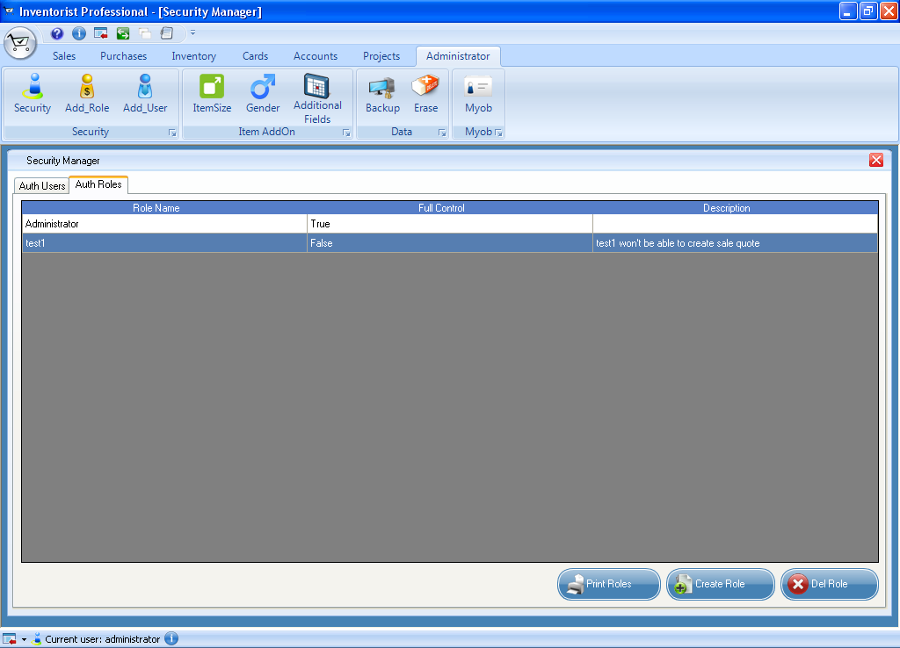

Figure 12: Window showing list of roles

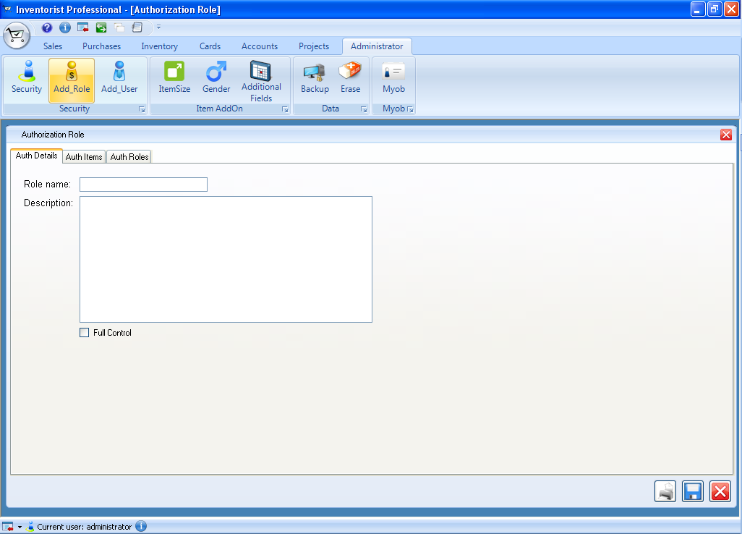

Figure 13: Dialog to create new role

## 2.7 Creating New item size

Item size can also be defined and created. To create new item size, log in to DacII as user with administrator role (log in as default user). After that, do the following steps to add new item size:

1. Log in as user with administrator role
2. Go to **Administrator ribbon Tab** and click **ItemSize button**
3. Click **Create Item Size button** which is at the bottom corner of the window.
4. Type Item ID which can be short form of item name and description.

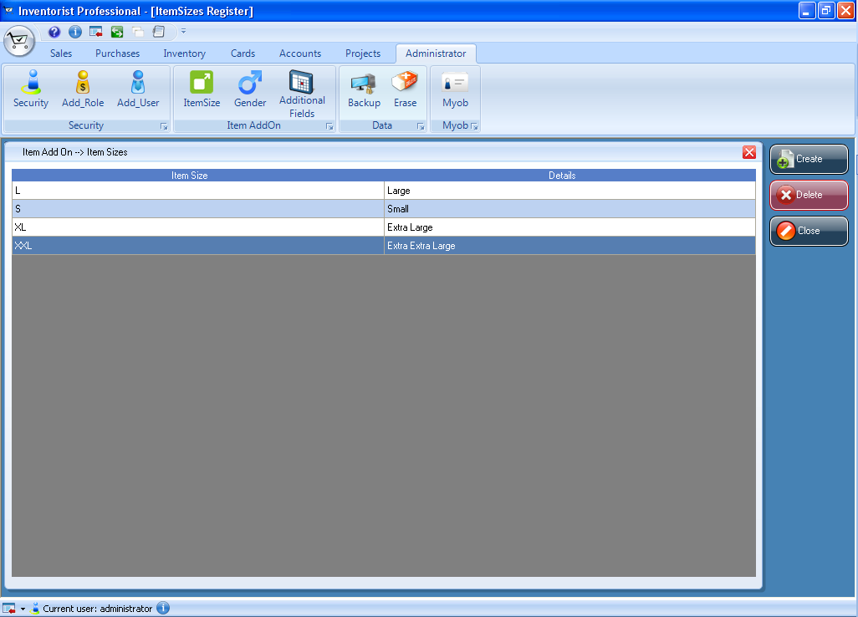

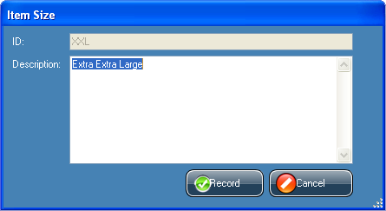

Figure 14: Window showed list of items created and dialog to create new item list

## 2.8 Creating new gender

Gender description can be defined and created by user and it can also be deleted. The purpose of having this feature is to allow user to use when they need for the system. To create new gender, log in to DacII as user with administrator role (log in as default user). After that, do the following steps to add new gender:

1. Log in as user with administrator role
2. Go to **Administrator ribbon Tab** and click **Gender button**
3. Click **Create Gender button** which is at the bottom corner of the window.
4. Type gender ID which can be short form of gender name and description.

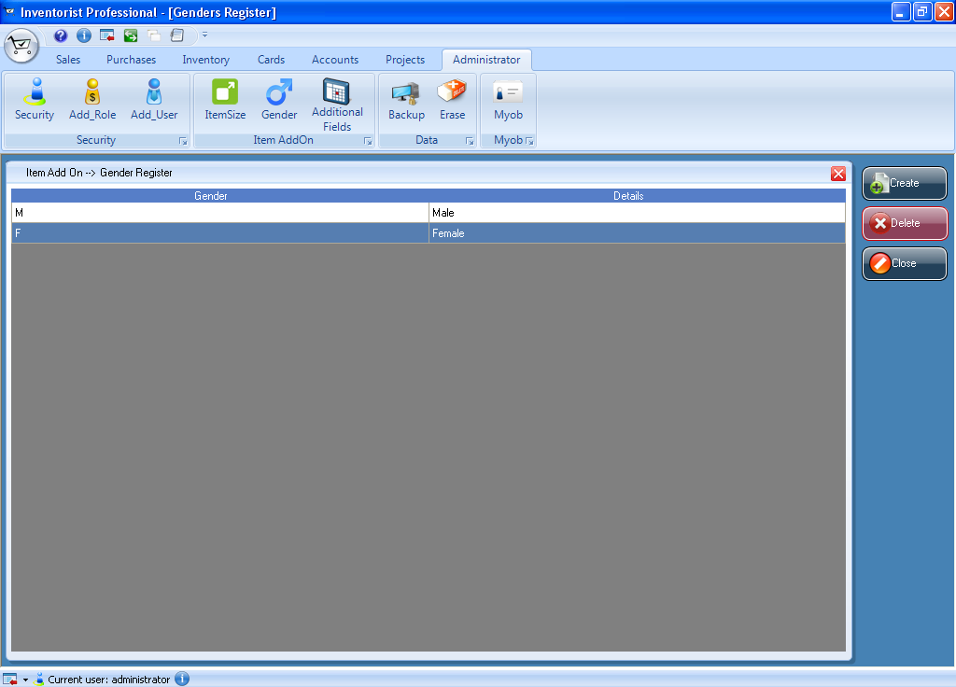

Figure 15: Window showed list of gender

## 2.9 Creating new additional fields

Any of additional field can be defined and created by user and it can also be deleted. Additional field can be any field related to products or user information and so on (example: Product Code). To create new additional field, log in to DacII as user with administrator role (log in as default user). After that, do the following steps to add new additional field:

1. Log in as user with administrator role
2. Go to **Administrator ribbon Tab** and click **Additional Fields button**
3. Click **Create Data Fields button** which is at the bottom corner of the window.
4. Type Data field name and choose data field type from the drop down list.

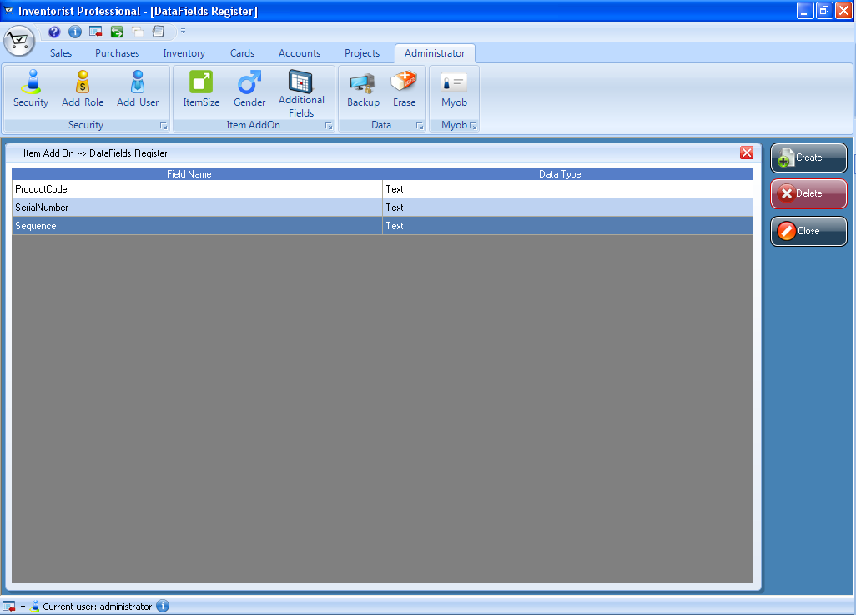

Figure 16: Window showed list of additional fields

# Chapter 3 Sales

This chapter explains all important information about sales and it can be referred to know how to put information about sales. A sale can be recorded by specifying the customer’s details and the invoice layout, which can be professional, service, item, time billing, miscellaneous or non-default. It can also be recorded by specifying the status of the sale such as quote, order or invoice. This chapter will also explain how to search and analyse sales activity.

## 3.1 Creating Customer card

Customer list can be viewed or created using feature called cards which will make up customer list. Customer name and all information created in customer card will be used to create sale transaction. You can also create other cards such as employee card and supplier card. To create a customer card, go to **Cards ribbon Tab** and follow the steps below.

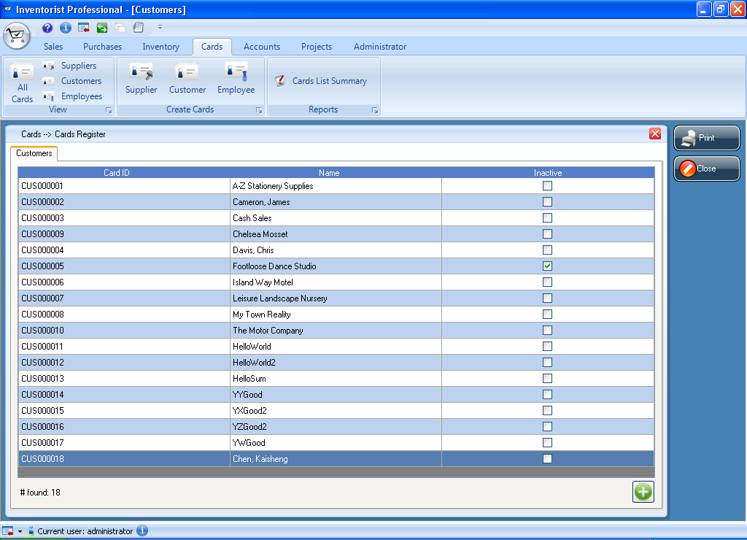

**List of customers created**

Figure 17: Window showing list of customers

1. Click **Cards ribbon Tab** and **Customers button** under **view** category. A list of customers which has been created will be displayed as shown in figure. Click **Create button** which is at the bottom corner of the window or
2. Click **Customer button** under **Create Cards** category
3. Customer dialog will be appeared and enter the customer’s contact details.
4. Click the Profile tab and select “is individual” check box if customer is individual (not company).
5. Enter the customer’s information such as name, card ID, address, email, phone number and other details.
6. If customer has more than one address (example: different shipping address), enter the address using different address tabs. You can enter up to five different addresses and other details for a customer.

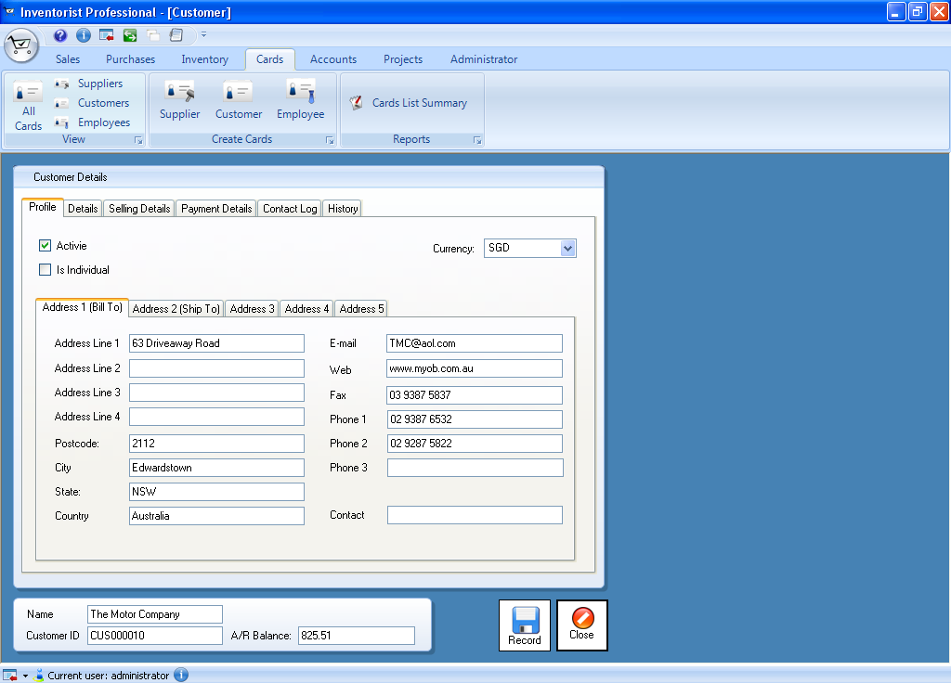

**Fill customer information**

Figure 18: Customer dialog showing profile page

1. Enter details of customer
2. Click the details tab and add picture of the customer ( refer to page222)
3. You can also add other information about customer in “Notes” text box.
4. Enter selling details
5. Click **Selling Details tab** and fill the details for selling information, tax information and credit terms.

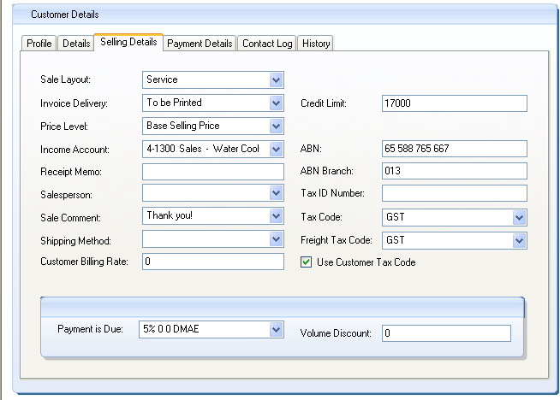

**Tax information**

**Selling information**

**Figure 19: Customer dialog showing selling details page**

1. Enter payment details
2. Click **Payment Details tab**
3. Choose the payment method that the customer frequently uses for payment. Payment method includes cash, visa, master cards and other methods. The purpose of entering payment details is to save time for point of sale.
4. Enter sale history
5. Click the History tab
6. Enter information for customer latest sale and monthly sales figures. That information will be optional for you to enter.
7. Click Record button at the bottom corner of the window after all information are entered.
8. You can repeat from step 1 to 7 for creating each of the customer cards.

## 3.2 Entering Sales

Each of sales can be recorded as quote, order or invoice.

**Quote** A quote will not affect your inventory levels and it records the estimated price information that has been sent to the customer. It can be changed to an order or an invoice when the customer is willing to buy.

**Order** When customer make a sale but no services or goods have been delivered, an order can be recorded for that sale. Orders will affect the inventory numbers and it will not affect the financial figures. Only when customer has paid you a deposit, transactions can be created.

**Invoice** An invoice can be created when services or goods are delivered to your customer. An invoice cannot be changed to a quote or an order.

### 3.2.1 Create sale quote

Do the following steps to create new sale quote:

1. Go to **Sales ribbon tab** and click **Quote button or**
2. Click **Register button** and go to **Sale Quotes tab**
3. A list of sale quotes will be appeared when you choose the date.
4. Click **Create Quote button** and sale quote dialog will be appeared.
5. Choose the customer name from drop down menu and all the information related to that customer will be appeared as default. List of customer name which you created in customer cards are appeared in menu.

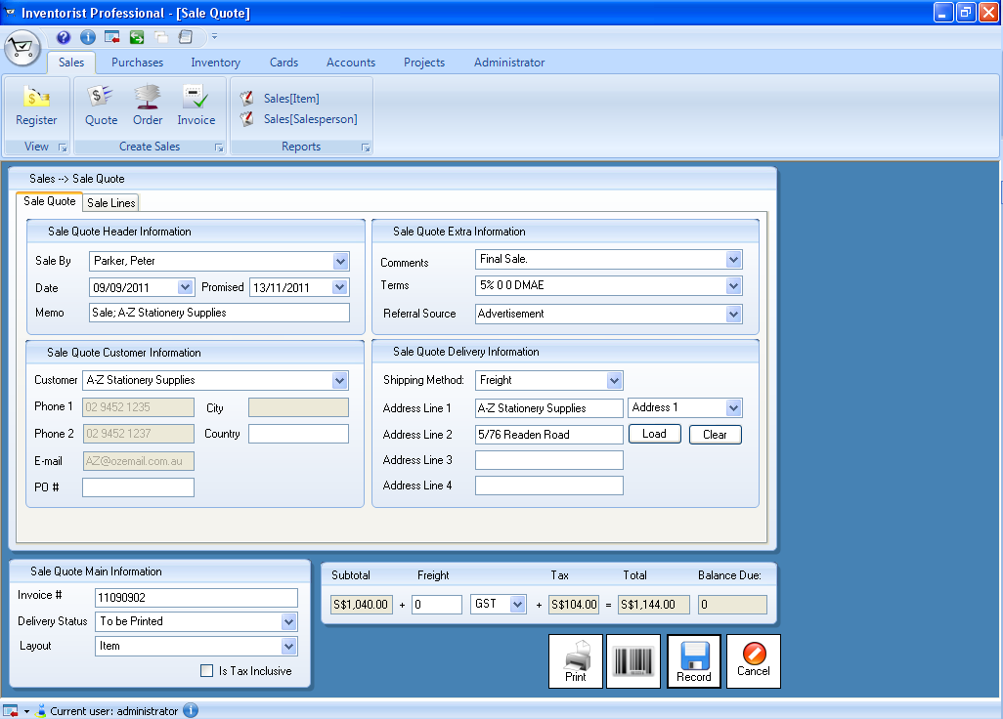

**Click this button to get back default address**

**Click this button to clear default address**

**All information of the customer is appeared automatically**

**Choose the customer name from the drop down menu**

Figure 20: Sale quote dialog

1. Enter other information such as sale person, comments and other address.
2. If you want to add sale line to this sale quote, choose the layout and go to Sale Line tab
3. Click **Create Line button** and fill the information according to the layout that you are using. After you fill all the information for sale line, you can click **Record button** to save the sale line. You can add as many line items for a sale as you want.

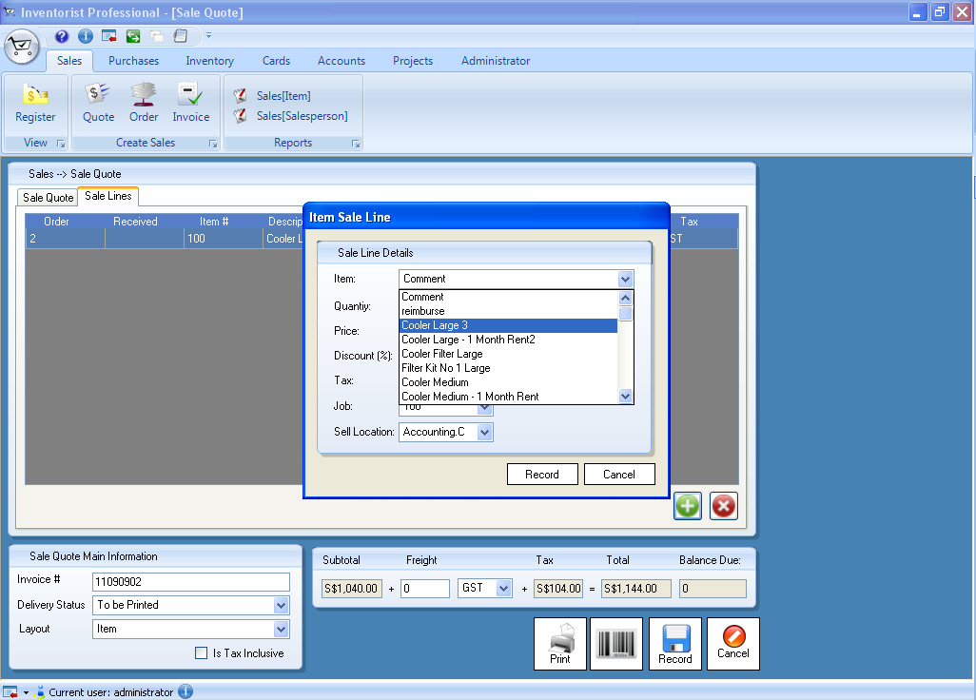

**Related sale line dialog will be appeared according to the layout you choose**

**Figure 21: Sale quote window and service sale line dialog**

1. After all information is filled, click **Update button** to save the sale quote.
2. If you want to print, click **Print button.**

### 3.2.2 Create sale order and sale invoice

To create sale order and sale invoice, all the steps from step one to step 10 of creating sale quote can be used.

## 3.3 Converting the sale quote to a sale order or an invoice

To convert a sale quote to an order or invoice, you can follow the steps

1. Go to **Sales ribbon tab** and click **Register button** and go to **Sale Quotes tab**
2. A list of sale quotes will be appeared when you choose the date.
3. Click **Change to Order button** if you want to change to an order.
4. Click **Change to Invoice button** if you want to change to an invoice.
5. Same procedure can be used to change to an invoice from a sale order.

# Chapter 4 Purchase

This chapter explains all important information about purchases and it can be referred to know how to put information about purchases. A purchase can be recorded by specifying the supplier’s details and the purchase layout, which can be professional, service, item, time billing, miscellaneous or non-default. It can also be recorded by the status of the purchase form such as quoted, ordered or billed. This chapter will also explain how to search and analyse purchase activity.

## 4.1 Creating Supplier card

Supplier list can be viewed or created using feature called cards which will make up supplier list. Supplier name and all information created in supplier card will be used to create purchase transaction. You can also create other cards such as employee card and sales card. Creating sales card is already explained in chapter 3.2. To create a supplier card, go to **Cards ribbon Tab** and follow the steps below.

1. Click **Cards ribbon Tab** and **Suppliers button** under **view** category. A list of suppliers which has been created will be displayed as shown in figure. Click **Create button** which is at the bottom corner of the window or
2. Click **Supplier button** under **Create Cards** category

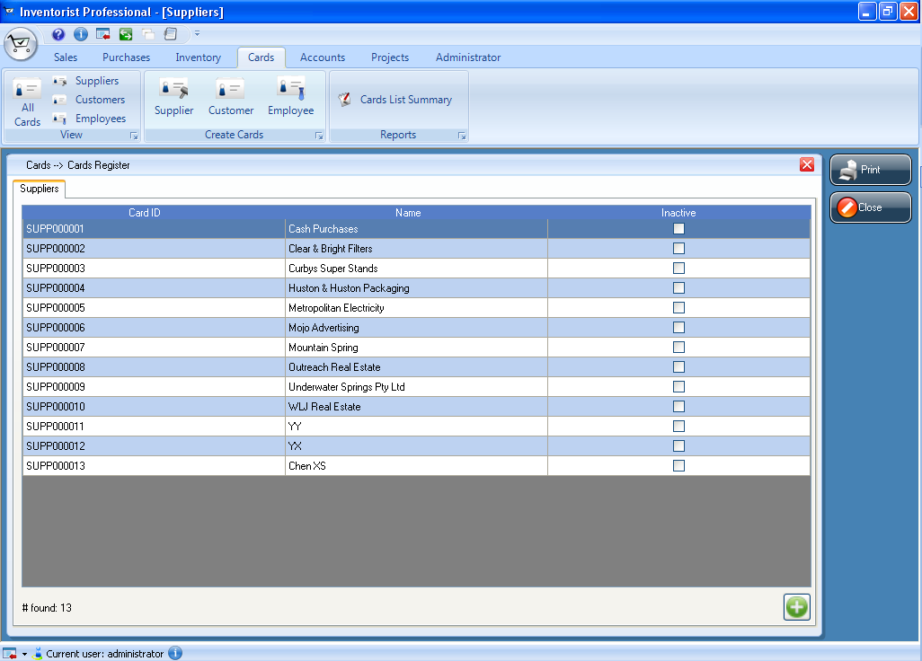

**List of suppliers created**

Figure 22: Window showing list of suppliers

1. Supplier dialog will be appeared and enter the supplier’s contact details.
2. Click the Profile tab and select “is individual” check box if supplier is individual (not organization).
3. Enter the supplier’s information such as name, card ID, address, email, phone number and other details.
4. If supplier or company has more than one address (example: different P.O box and street address), enter the address using different address tabs such as address2 etc. You can enter up to five different addresses and other details for a customer.

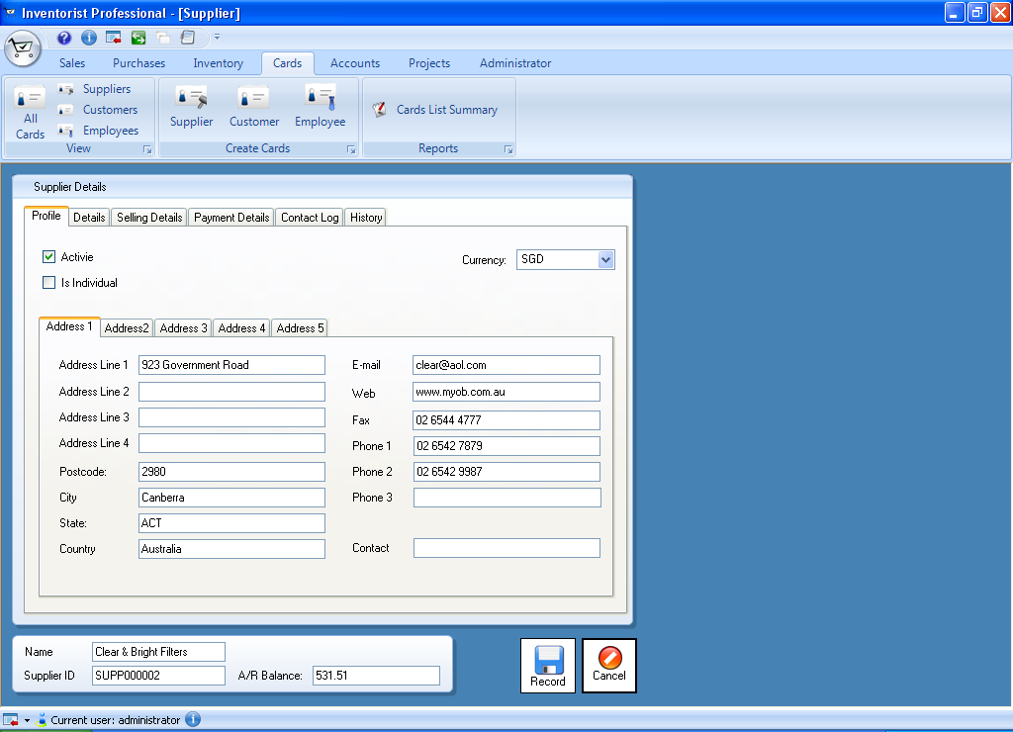

**Fill supplier information**

**Figure 23: Supplier dialog**

1. Enter details of supplier
2. Click the details tab and add picture of the supplier ( refer to page222)
3. You can also add other information about supplier in “Notes” text box.
4. Enter selling details
5. Click **Selling Details tab** and fill the details for selling information, tax information and credit terms.

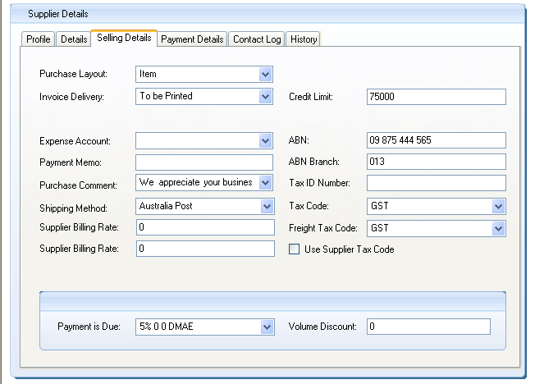

**Credit term**

**Tax information**

**Buying information**

**Figure 24: Supplier dialog showing selling details page**

1. Enter payment details
2. Click **Payment Details tab**
3. Enter payment details such as BSB number, bank account number and bank account name. The purpose of entering payment details is to save time for point of sale.
4. Enter purchasing history
5. Click the History tab
6. Enter information for supplier such as when your company starts to purchase from the supplier, latest purchasing and monthly purchase figures. That information will be optional for you to enter.
7. After all information are entered click Record button at the bottom corner of the window.
8. You can repeat from step 1 to 7 for creating each of the customer cards.

## 4.2 Entering Purchases

Each of purchases can be recorded as quote, order or bill.

**Quote** A quote can be recorded to keep a record of an estimate or quote you received from one of your suppliers. It will not affect your inventory levels and it can be changed to an order or a bill when you are willing to purchase.

**Order** When you make a purchase but no services or goods have been delivered, an order can be recorded for that purchase. Orders will affect the inventory numbers and it will not affect the financial figures. Only when you have paid a deposit to the supplier, transactions can be created.

**Bill** A bill can be created when services or goods are delivered to you and you are required to pay to the supplier. A bill cannot be changed to a quote or an order.

### 4.2.1 Create purchase quote

Do the following steps to create new purchase quote

1. Go to **Purchases ribbon tab** and click **Quote button or**
2. Click **Register button** and go to **Purchase Quote tab**
3. A list of purchase quotes will be appeared when you choose the date.
4. Click **Create Quote button** and **Purchase Quote** dialog will be appeared.
5. Choose the supplier name from drop down menu and all the information related to that customer will be appeared as default. List of supplier name which you created in supplier cards are appeared in that drop down menu.

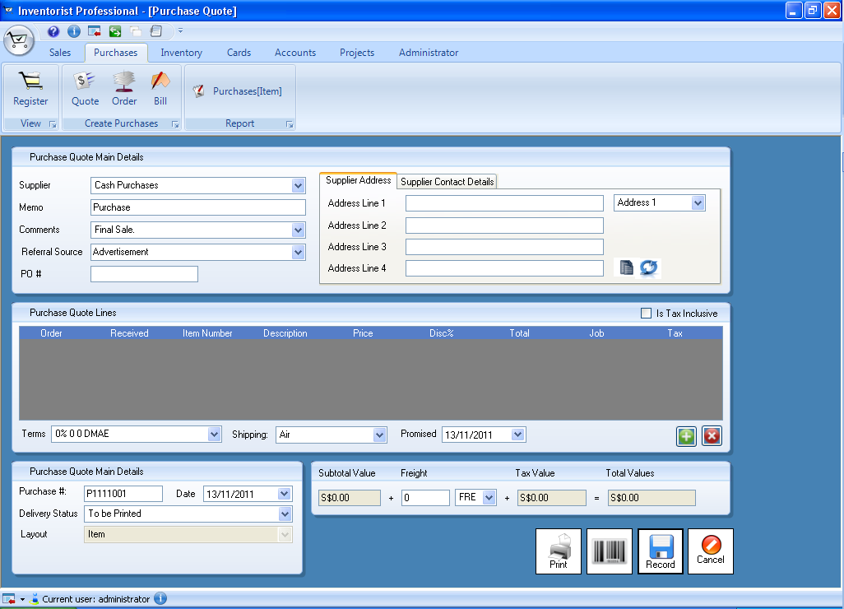

**Click this button to clear default address**

**Click this button to clear default address**

**All information of the supplier is appeared automatically**

**Choose the supplier name from the drop down menu**

**Figure 25: Purchase quote dialog**

1. Enter other information such as comments and other address.
2. If you want to add purchase line to this purchase quote, choose the layout you want and go to Purchase Line tab.
3. Click **Create Line button** and fill the information according to the layout that you are using. After you fill all the information for purchase line, you can click **Record button** to save the purchase line. You can add as many line items for a purchase as you want.

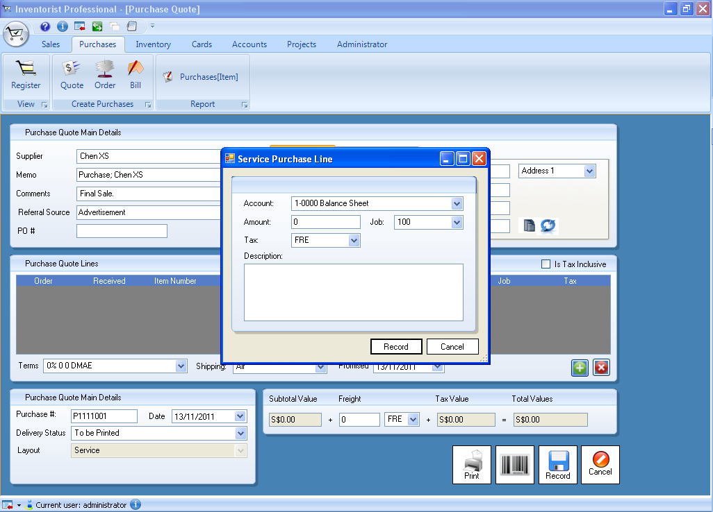

**Related purchase line dialog will be appeared according to the layout you choose**

**Figure 26: Purchase quote window and service purchase line dialog**

1. After all information is filled, click **Update button** to save the purchase quote.
2. If you want to print the purchase quote, click **Print button.**

### 4.2.2 Create purchase order and open bill

To create purchase order and open bill, all the steps from step one to step 10 of creating purchase quote can be used.

## 4.3 Converting the purchase quote to a purchase order or a bill

To convert a purchase quote to a bill or a purchase order, you can follow the steps

1. Go to **Purchases ribbon tab** and click **Register button** and go to **Purchase Quotes tab**
2. A list of purchase quotes will be appeared when you choose the date.
3. Click **Change to Order button** if you want to change to an order.
4. Click **Change to Invoice button** if you want to change to a bill.
5. Same procedure can be used to change to a bill from a purchase order.

# Chapter 5 Inventory

This chapter explains all important information about items that you buy, sell and build. The inventory features allows you to track the quantity and value of the items. You may need to track the items as there may be variations caused by data-entry errors and theft etc. Before you track the items you need to create a record for each item of inventory. This chapter will explain how to create the items.

## 5.1 Creating Items

Each of items can be physical unit that your company buys; sells or inventories- for example, books, computers, water bottles etc. It can also be a service that your company may include on item invoices, for example, shipping, handling, and labour etc. When you record the item, you can choose the function that you want to use the item with. You can choose buy, sell or inventory the item. For example, if you want to include a service item on an invoice, you need to specify that you sell the item.

**I buy this item** Indicates that this is the item or service you want to add to an item purchase order. It includes the items for office use and not for resale. For example, raw materials you use as components to make other items.

**I sell this item** Indicates that this is the item or service you want to add to an item invoice order.

**I inventory this item** Indicates that this is the item that you buy or sell and you want to track its quantities and values.

Do the following steps to create new item

1. Go to **Inventory ribbon tab** and click **Item button**
2. **Item profile window** will be appeared.
3. Enter the category of the item and other information such as item name, item number etc.
4. Choose the function that you buy, sell or inventory the item. If you choose to inventory the item, you need to enter information only for item profile and item details.
5. If you choose to inventory the item, you need to choose asset account for inventory.
6. If you choose to buy the item, you need to choose cost of sales account.
7. If you choose to sell the item, you need to choose tracking sales.

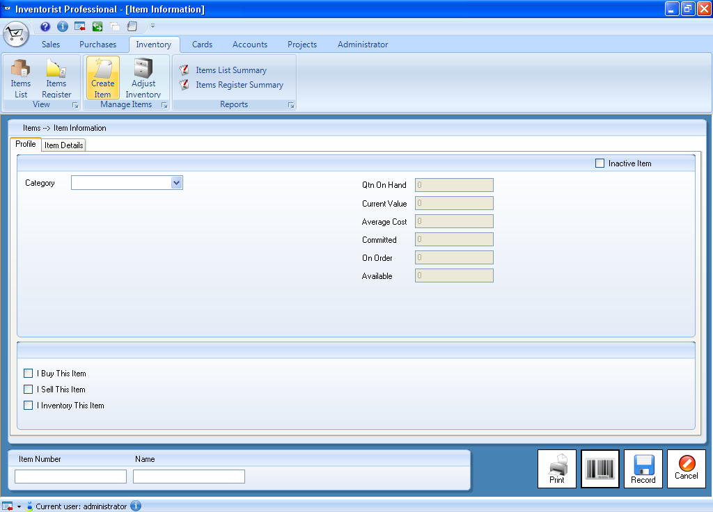

**Enter category**

**Information for profile and item details needs to be filled if inventory is chose**

**Choose to buy, sell and fill related information**

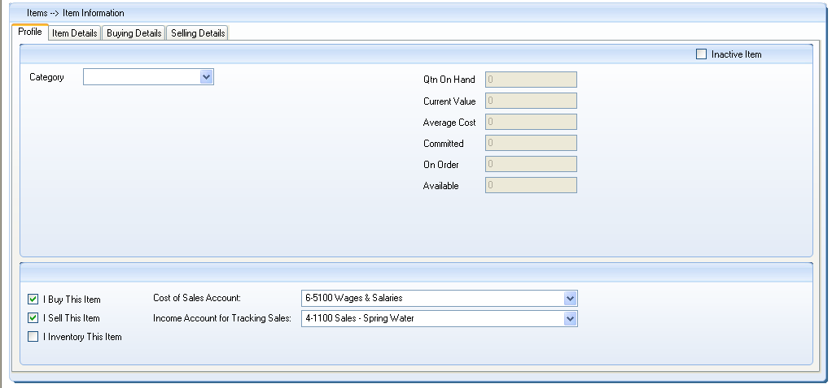

**Information for buying details and selling details can be entered if buy or sell the item is chosen**

**Figure 27: Item window showing profile page**

1. Enter details of item
2. Click the details tab and add picture of the item
3. You can also add location and other information about supplier in “Description” text box.
4. If you choose buy or sell the item you also need to enter the information for buying details and selling details as shown in figure 27.
5. To enter information for buying details according to the figure and guide as shown below.

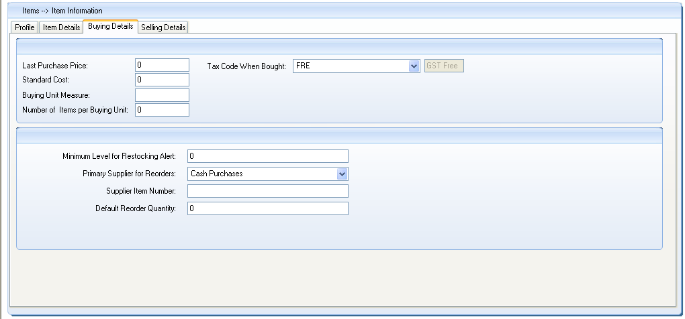

**B**

**A**

Figure 28: Item window showing buying details page

1. Buying information such as last purchase price, standard cost, buying unit of measure and number of items per buying unit.

* Buying unit of measure is the unit of measure in which you purchase the item.
* Number of items per buying unit is the number of items that include a single buying unit (for example: if you buy books by one dozen and track their purchases as individual units, you need to enter 12 as the number of items per buying unit.

1. Restocking information such as minimum level of restocking alert and primary supplier information.

* Minimum level of restocking is the minimum level of the item you want to keep in your inventory. When the quantity level is lower than this level, reminder will be appeared.
* Primary supplier is the supplier from whom you normally order this item.

1. To enter information for selling details according to the figure and guide as shown below.

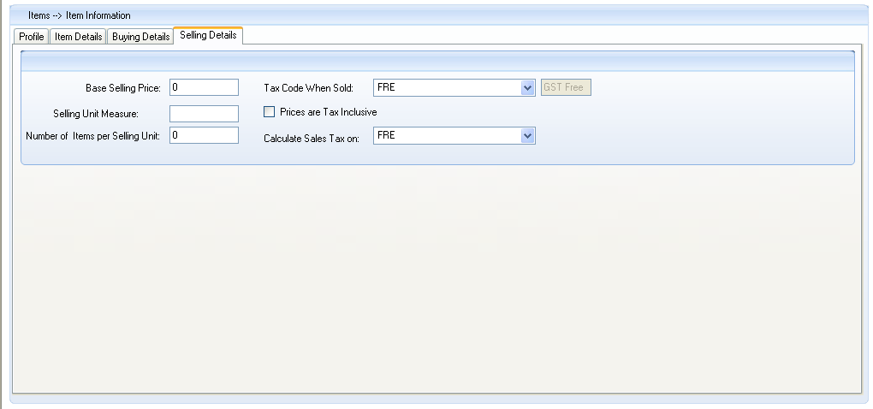

**B**

**A**

**Figure 29: Item window showing selling details page**

1. Selling information such as base selling price, selling unit measure and number of items per selling unit.

* Buying unit of measure is the unit of measure in which you purchase the item.
* Number of items per buying unit is the number of items that include a single buying unit (for example: if you buy books by one dozen and track their purchases as individual units, you need to enter 12 as the number of items per buying unit.

1. Restocking information such as minimum level of restocking alert and primary supplier information.

* Minimum level of restocking is the minimum level of the item you want to keep in your inventory. When the quantity level is lower than this level, reminder will be appeared.
* Primary supplier is the supplier from whom you normally order this item.

1. After all information is entered, click **Record button** or if you want to cancel to create item click **Cancel button.**

### 5.1.1 Average Cost, Last Cost and Standard Cost

**Average cost** is calculated as the total cost of an item divided by the number of units of that item you have on hand**. Last Cost** is the most recent purchase price for the item. **Standard Cost** can be used instead of the last purchase price as the default price on purchases.

## 5.2 Reviewing inventory information

The **Items Register** window allows you to access to transactions relating to items. To see the **Items Register** window:

1. Go to **Inventory ribbon tab** and click **Items Register button**. The **Items Register window** will be appeared.

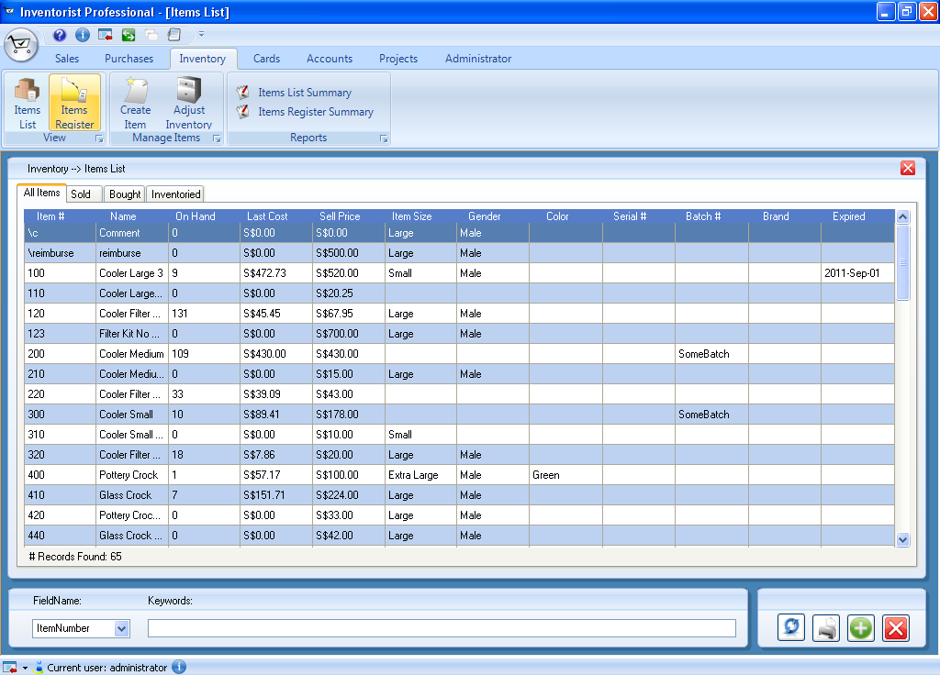

**Showing all items**

**Figure 30: Item register window**

1. You can view transactions for all items or a single item. If you want to view for an item, select the item number in the Item field. You can find items according to name, number and description.
2. In the **Date From** and **To** fields, enter the date range where the transaction was recorded. The transactions that, are recorded within the period you entered, will be displayed in the **Items Register window.**

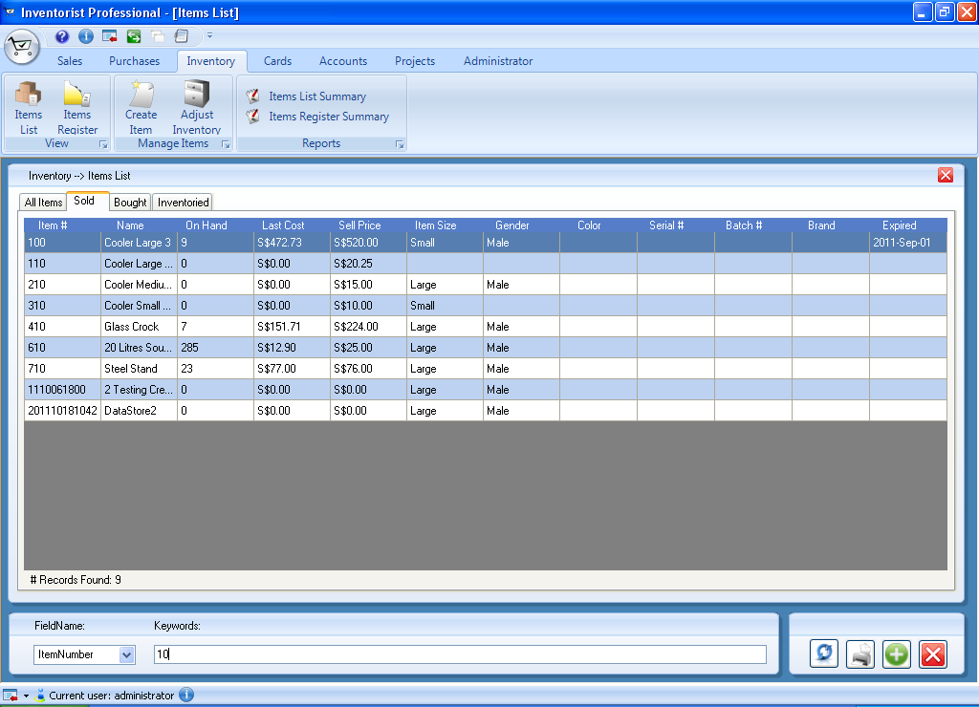

**Showing items according to search results**

## 5.3 Changing Transaction

# Chapter 6 Setting up Employee data

## 6.1 Creating Employee Card

Employee list can be viewed or created using feature called cards which will make up employee list. Employee name and all information created in employee card will be used to create sale or purchase transaction. You can also create other cards such as customer card and supplier card. To create an employee card, go to **Cards ribbon Tab** and follow the steps below.

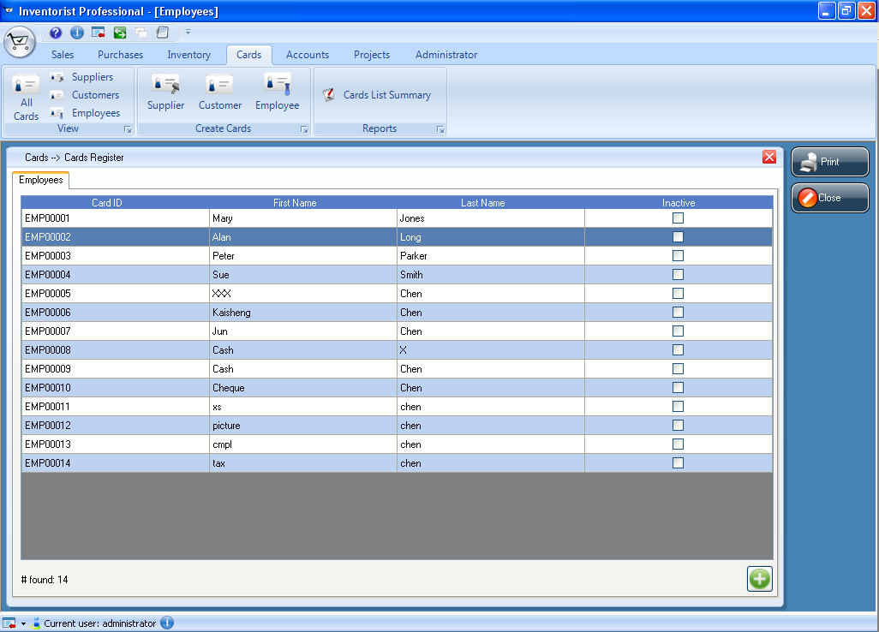

Figure 31: Employees window

1. Click **Cards ribbon Tab** and **Employees button** under **view** category. Click **Create button** which is at the bottom corner of the window or
2. Click **Employee button** under **Create Cards** category
3. Employee dialog will be appeared and enter the employee’s contact details.
4. Click the Profile tab and select “is individual” check box if employee is individual.
5. Enter the employee’s information such as name, card ID, address, email, phone number and other details.
6. If employee has more than one address (example: different mailing address), enter the address using different address tabs. You can enter up to five different addresses and other details for an employee.

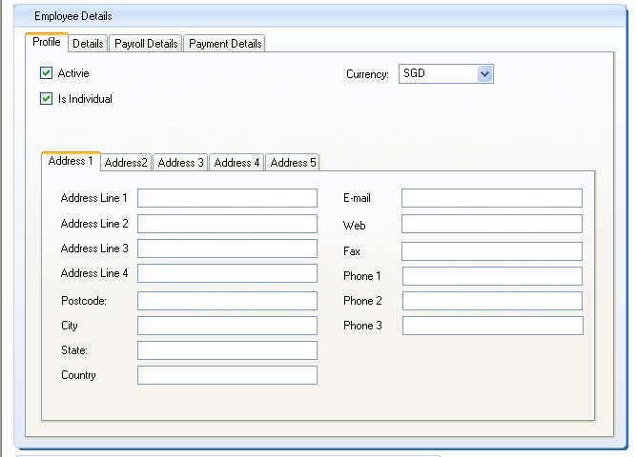

**Fill employee information**

Figure 32: Employee dialog showing profile page

1. Enter details of employee
2. Click the **Details** tab and you can add other information about employee in “Notes” text box.
3. Enter basic salary
4. Click the **Billing Details** tab and enter basic salary of the employee
5. Click Record button at the bottom corner of the window after all information are entered.
6. You can repeat from step 1 to 7 for creating each of the employee cards.

# Chapter 7 Working with accounts

## 7.1 Deleting user

To delete the user from the list,

1. Log in as user with administrator role
2. Go to **Administrator ribbon Tab** and click **Security button**
3. Choose Auth Users button and choose the user that you want to delete and click **Delete User button** which is at the bottom corner of the window



Figure 33: Window showing list of users

## 7.2 Deleting role

To delete the role from the list,

1. Log in as user with administrator role
2. Go to **Administrator ribbon Tab** and click **Security button**
3. Choose Auth Roles button and choose the role that you want to delete and click **Delete Role button** which is at the bottom corner of the window



Figure 34: Window showing list of roles

## 7.3 Deleting item size

To delete the Item size that is defined by user from the list:

1. Log in as user with administrator role
2. Go to **Administrator ribbon Tab** and click **ItemSize button**
3. Choose the item size that you want to delete from the list and click **Delete ItemSize button** which is at the bottom corner of the window



Figure 35: Window showing list of items

## 7.4 Deleting gender

To delete the Item size that is defined by user from the list:

1. Log in as user with administrator role
2. Go to **Administrator ribbon Tab** and click **Gender button**
3. Choose the gender type that you want to delete from the list and click **Delete Gender button** which is at the bottom corner of the window



Figure 36: Window showing list of gender

## 7.5 Deleting additional fields

To delete the additional field that is defined by user from the list:

1. Log in as user with administrator role
2. Go to **Administrator ribbon Tab** and click **Additional Fields button**
3. Choose the field that you want to delete from the list and click **Delete Data Field button** which is at the bottom corner of the window



Figure 37: Window showing list of additional fields

## 7.6 Updating the Customer card

You can update the information of the customers. To update the information you can do the following steps.

1. Go to **Cards ribbon tab** and click **Customers button** under view feature group
2. A list of customers created will be appeared in the form of table.
3. Each row contains the information of one customer as shown in figure.
4. Double-click on one of the row showing the customer information that you want to update.
5. **Customer dialog** will be displayed and you can update the information.
6. After updating the information, click the **Update button**.



**One row represents the information for one customer**

Figure 38: Customer window

## 7.7 Updating the Supplier card

You can update the information of the suppliers. To update the information you can do the following steps.

1. Go to **Cards ribbon tab** and click **Suppliers button** under view feature group
2. A list of suppliers created will be appeared in the form of table.
3. Each row contains the information of one supplier as shown in figure.
4. Double-click on one of the row that you want to update.
5. **Supplier dialog** will be displayed and you can update the information.
6. After updating the information, click the **Update button**.



**One row represents the information for one supplier**

Figure 39: Supplier window

## 7.8 Updating the Employee card

You can update the information of the employees. To update the information you can do the following steps.

1. Go to **Cards ribbon tab** and click **Employees button** under view feature group
2. A list of employees created will be appeared in the form of table.
3. Each row contains the information of one employee as shown in figure.
4. Double-click on one of the row that you want to update.
5. **Employee dialog** will be displayed and you can update the information.
6. After updating the information, click the **Update button**.

# Chapter 8 Working with data

## 8.1 Backup and restore

User can backup or restore data that they are processing. There are two types of backing up, database backup and cloud backup. Explanation. How to backup data will be explained steps by steps as the following.

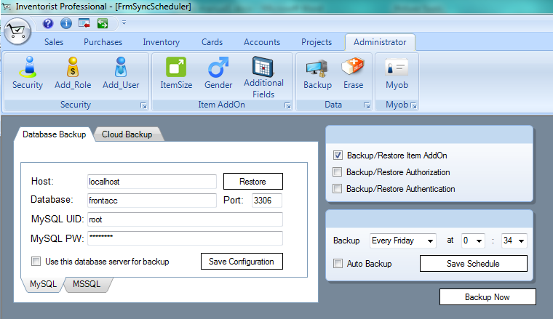

**If you want to use this server to back up click the check box**

**Host should be local host**

**Set date and time for auto backup**

**Choose what you want to back up or restore**

Figure 40: Backup window

If you do not MySQL or SQLServer installed and configured, make sure the “NETWORK” tab has set the data source to local, as shown in (Note that this is the default).

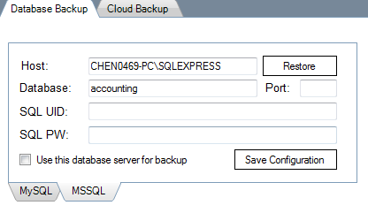

Figure 41: Backup window showing information for MSSQL page

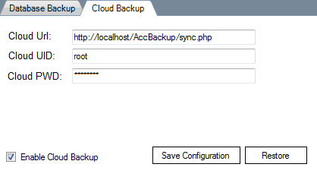

Figure 42: Backup window showing for cloud backup page

## 8.2 Erase the contents

User can erase contents which are Item add on, authorization, authentication and data fields. User can choose any of them to erase them from the system. If user chooses any of them and click erase button, confirmation dialog comes out as the data cannot be recovered after erasing.

To erase contents, log in to DacII as user with administrator role (log in as default user). After that, do the following steps:

1. Log in as user with administrator role
2. Go to **Administrator ribbon Tab** and click **Erase button**
3. Choose any of the contents and click **Erase Now button** which is at the bottom.
4. Erase confirmation dialog will be appeared.

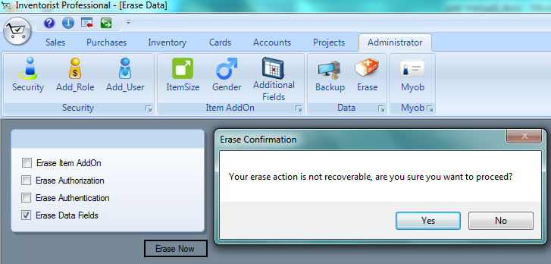

**Can choose more than one contents**

Figure 43: Erase contents window

# Chapter 9 Working with projects and jobs

## 9.1 Reviewing the projects

User can check all the projects and their related job information under them.

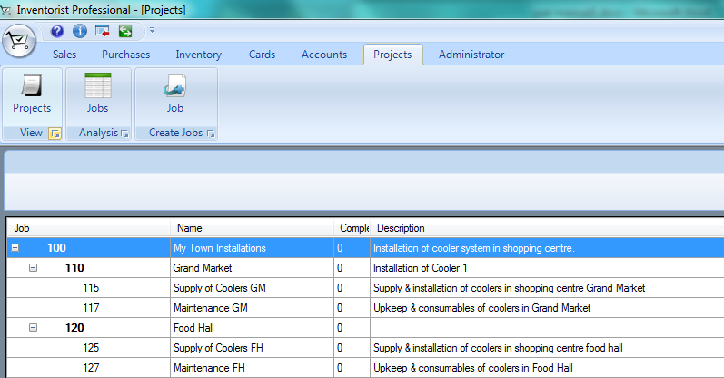

**List of the projects**

Figure 44: Projects window

## 9.2 Updating the project

User can also update the information of the projects. To update the project information, do the following steps:

1. Log in as user with any role
2. Go to **Projects ribbon Tab** and click **Projects button**
3. Lists of the project or job will be appeared and choose any of the projects and double click on it.
4. Dialog comes out and click Record button after changing the information.

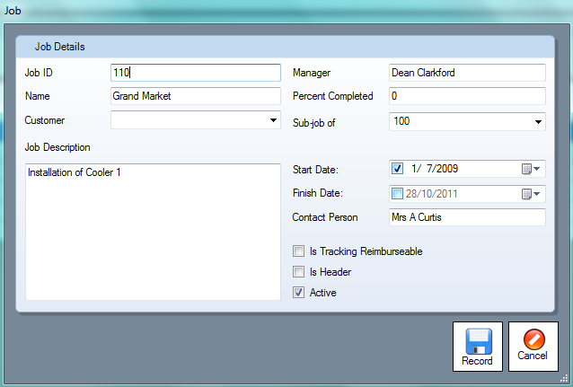

**Can update the information of the projects**

Figure 45: Job dialog

## 9.3 Reviewing the Jobs

User can check all the projects and their related job information under them. To view the projects

1. Go to **Projects ribbon Tab** and click **Projects button**
2. Lists of the project or job will be appeared and choose any of the projects.

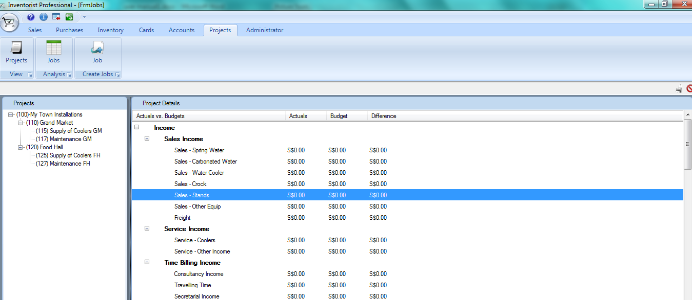

**List of information related to the job that you choose will be displayed**

Figure 46: Job window showing information for jobs